Low Level Design (booking Service module)

|  |  |
| --- | --- |
| **Project Code** | Team1 |
| **Project Name** | Hotel Management System |

|  |  |  |
| --- | --- | --- |
| **Prepared/Modified by** | **Role** | **Date of Preparation** |
| Jerry Jose | Analyst | 17/10/2018 |
| **Reviewed by** | **Role** | **Date of Review** |
| Vyankateshprasad Kulkarni | Analyst | 18/10/2018 |
| **Approved by** | **Role** | **Date of Approval** |
| Yogini Nayak | Training Mentor |  |
| **Circulation List** | Harshit.srivastva@capgemini.com, [nishant.joshi@capgemini.com](mailto:sania.a.khan@capgemini.com,kartik.tiwari@capgemini.com), jerry.jose@capgemini.com, vyankateshprasad.kulkarni[@capgemini.com](mailto:shashank.dwivedi@capgemini.com), [satyam.kashmiri@capgemini.com](mailto:swati.nenawat@capgemini.com) | **Version Number of the template:1.0** |
| **Version Number** | 1.3 |  |

Table of Contents

1. Description Of The Unit 3

2. References 4

3. Dependencies / Assumptions 5

4. Class Diagrams 6

5. Sequence Diagrams 7

6. Design Components 8

6.1 List Of UI Components 8

6.2 List Of Design Classes 8

7. Re-Usable Routines/Components 9

8. Messages 10

9. Configuration Files 11

10. Crud Matrix Table 12

11. Data Mapping Matrix 13

12. Action Flow Matrix 14

13. Stored Procedures 15

14. Program Specification / Pseudo Code 16

REVISION HISTORY OF THE WORK PRODUCT 17

# Description Of The Unit

The add product module allows the admin of the application to add new hotels into the database. This module can be used only by the admin of the application.

On selecting on the add button in the admin home page, the admin is redirected to a add page. The admin enters all the details of the room like Hotel name, room description, room type, room price and room quantity. If the entered details are invalid, appropriate error messages are displayed.

After entering all the room details, the details are inserted into the database on clicking the add button. The admin can also cancel the add product functionality by clicking on the cancel add button.

# References

| **Reference** | **Description** |
| --- | --- |
| Repository reference | https://IGTEBLRSVNTNG.igatecorp.com/svn/oct3_Team1 |
| Class Diagram | /Project Documents/Design Documents/HLD/Class Diagrams |
| URS | /Project Documents/Requirements/Case Study/Ecommerce-grp1 and grp3.doc |
| UTP | /Project Documents/Test Plan/UTP/Test Cases/AddProduct /UTP_AddProductModule.xlsm |
| DB Design | /Project Documents/Design Documents/HLD/DB Design/E-Commerce_GROUP_DBDESIGN.xls |

# Dependencies / Assumptions

**Dependencies:**

The admin should be logged in.

**Assumptions:**

The admin details are stored in the database.

# Class Diagrams

[Class Diagram](../../HLD/Class%20Diagrams)

# Sequence Diagrams

|  |
| --- |
| **Sequence Diagram** |
| NA |

# Design Components

## List Of UI Components

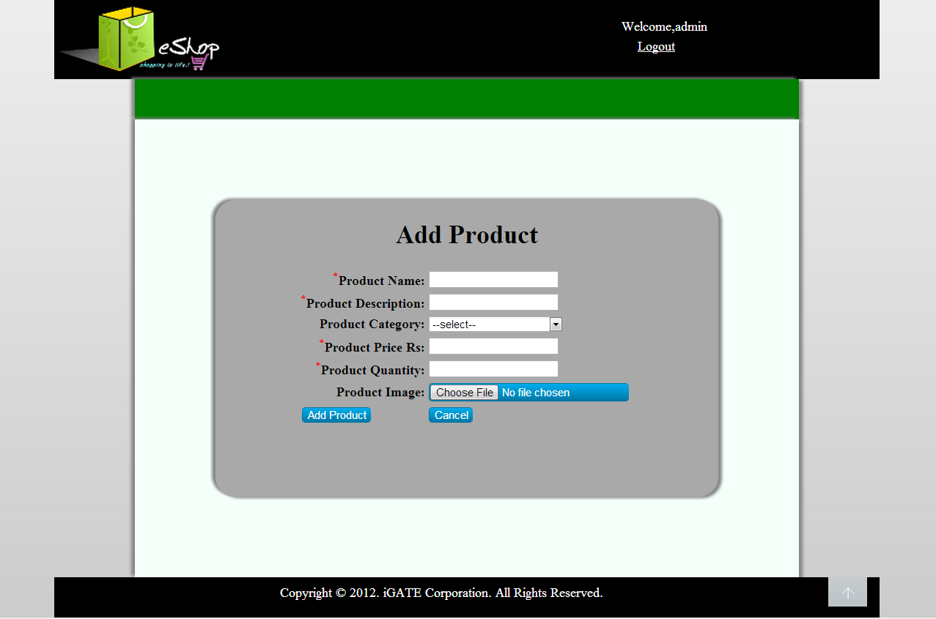

|  |  |  |  |  |
| --- | --- | --- | --- | --- |
| **Sr. No.** | **LLD Name** | **Class Name** | **Method Name** | **Method Description** |
| 1 | BookingService Module | BookingDetails | Appropriate variables and their getters and setters methods | Getters retrieve the property values and setters set the property values |
| 2 | BookingService Module | BookingServiceController | insert(@RequestBody HotelDetails room), select(@PathVariable(”bookingId”)), | Requests appropriate Hotel Details object, HotelId according to function called with appropriate error message. |
| 3 | BookingService Module | Response Client | ResponseClient(), getResponse(), setResponse() | Constructor to pass message, getter and setter functions. |

## List Of Design Classes

# Re-Usable Routines/Components

Re-Usable Routines/Components

* BookingDetails class

# Messages

|  |  |  |
| --- | --- | --- |
| **#.** | **Type** | **Message Text** |
| M1 | Error | Enter a valid name |
| M2 | Error | Enter a valid description |
| M3 | Error | Enter a valid sub-category |
| M4 | Error | Enter a valid price |
| M5 | Error | Enter a valid quantity |
| M6 | Error | This field cannot be empty |

# Configuration Files

|  |  |  |
| --- | --- | --- |
| File Name | Path | Description |
| oracle.properties | /Development/Source | To configure database connection. |
| Web.xml | /Development/Source | To configure the bean properties. |
| Dispatcher-servlet.xml | /Development/Source | To configure the request mapping and view resolver. |
| Eshop_logger.properties | /Development/Source | To configure the logger. |
| Eshop_error.properties | /Development/Source | To configure error messages. |

# Crud Matrix Table

|  |  |  |  |  |  |
| --- | --- | --- | --- | --- | --- |
| **#** | **Table Name** | **Create** | **Read** | **Update** | **Delete** |
| 1. | Product | Y | N | N | N |
| 2. | Product_Image | Y | N | N | N |
| 3. | Product_Sequence | N | Y | N | N |
| 4. | Sub_Category | N | Y | N | N |

# Data Mapping Matrix

|  |  |  |  |  |  |  |  |
| --- | --- | --- | --- | --- | --- | --- | --- |
| **Sr. No.** | **Screen Label** | **Field Source** | **Field Type** | **Data Type** | **Max Length** | **Data Flow** | **Mandatory** |
| 1 | Product Name | NA | Label | NA | NA | UI | NA |
| 2 | txtProductName | Product. Product_Name | TextBox | Varchar2 | 50 | UID | Yes |
| 3 | Product description | NA | Label | NA | NA | UI | NA |
| 4 | txtProductDescription | Product. Product_Description | TextBox | Varchar2 | 50 | UID | Yes |
| 5 | Product Sub-category | NA | Label | NA | NA | DUI | NA |
| 6 | optProductSubCategory | Product. Product_Sub_Category | Dropdown | Varchar2 | 50 | UID | Yes |
| 7 | Product Price | NA | Label | NA | NA | UI | NA |
| 8 | txtProductPrice | Product. Product_Price | TextBox | Decimal | (8,2) | UID | Yes |
| 9 | Product Quantity | NA | Label | NA | NA | UI | NA |
| 10 | txtQuantity | Product. Quantity | TextBox | Number | NA | UID | Yes |
| 11 | Product Image | NA | Label | NA | NA | UI | NA |
| 12 | fileProductImage | Product_Image. Image | File | Varchar2 | 50 | UI | Yes |
| 13 | Add | NA | Button | NA | NA | UI | NA |
| 14 | Cancel | NA | Button | NA | NA | UI | NA |

**Legend**

D UI (Database to User Interface)

UI D (User Interface to Database)

UI (User Interface Only)

# Action Flow Matrix

|  |  |  |  |
| --- | --- | --- | --- |
| **Sr. No.** | **Action** | **Description** | **Process** |
| 1 | On click of Add Button in Admin Homepage | Redirected to the Add page | The admin clicks on the add button in the admin homepage and gets redirected to the add page. |
| 2 | On click of Add Product button in add page | The room details are inserted into the database. | Data is entered in the fields by the admin which gets inserted into the database when add button is pressed. |
| 3 | On click of Cancel button in Add page | The product is not added into the database. | The admin on clicking on the cancel button in add page gets redirected to the home page. |

# Stored Procedures

|  |  |  |  |  |
| --- | --- | --- | --- | --- |
| **#** | **Stored Procedure Name**  **(with Description)** | **Input/Out Parameters** | **Type** | **Size** |
| 1. | NA | NA | NA | NA |

REVISION HISTORY OF THE WORK PRODUCT

|  |  |  |  |  |  |
| --- | --- | --- | --- | --- | --- |
| # | Date | Version # | Section Changed | Details of changes made | Approved By |
| 1 | 11/10/2018 | 1.0 | LLD prepared | N/A | Yogini Naik |
| 2 | 13/10/2018 | 1.1 | Reusable components,  Pseudo code | Reusable components added.  The pseudo code is modified as per the specified flow. | Yogini Naik |
| 3 | 18/10/2018 | 1.2 | Reusable components,  References,  Data Mapping Matrix. | Reusable Components added.  File name with relative path is added in the references section.  The name of text boxes(screen label is changed). | Yogini Naik |